HTML & CSS Quiz (100 Marks)

________________________________________________________________________________________________________________

Section A: Multiple Choice Questions (10 × 1 = 10 Marks)

(Each question carries 1 mark. Choose the correct option.)

Which of the following is NOT a valid heading tag in HTML?

**a) <h7>**

b) <h3>

c) <h5>

d) <h2>

What is the default alignment of text inside a <p> element in most browsers?

a) Center

**b) Left**

c) Right

d) Justify

Which tag is used to create italicized text that also adds semantic meaning of "emphasis"?

**a) <i>**

b) <b>

c) <em>

d) <strong>

Which attribute is mandatory when creating a table using <table> in HTML?

a) border

b) cellpadding

c) cellspacing

**d) None**

In an ordered list <ol>, what is the default type of list item marker?

a) Roman numerals

b) Alphabet letters

**c) Numbers**

d) Bullets

Which input type allows users to select multiple options at the same time in a form?

a) radio

b) checkbox

c) text

**d) select**

Which CSS property is used to combine multiple elements into a single line horizontally inside a <div>?

a) float

b) flex-direction

c) inline-block

**d) display**

If a flex container uses justify-content: space-between;, how will items be placed?

a) All items at the center

**b) Items at equal space from edges and between each other**

c) All items aligned to the left

d) All items aligned to the right

Which CSS position value places the element relative to the browser window, ignoring parent containers?

a) relative

**b) fixed**

c) absolute

d) sticky

What is the default value of the CSS position property?

a) absolute

b) relative

**c) static**

d) fixed

________________________________________________________________________________________________________________

Section B: Short Answer Questions (6 × 5 = 30 Marks)

(Each question carries 5 marks. Be logical and concise.)

1. Differentiate between <strong> and <b> tags with an example.

Ans. Both tags are used to make the text bold in overall context.  
e.g :

<p> Hello <b> World </b> </p>

<p> Hello <strong> World </strong> </p>

2. Explain the difference between ordered and unordered lists. Write the syntax for each.

Ans. The order list is used to arrange the items in a certain manner while in unordered list the items are arranged regardless of their order

Eg:

Code for ordered list

<ol>

<li>First item</li>

<li>Second item</li>

<li>Third item</li>

</ol>

Code for unordered list

<ul>

<li>Item one</li>

<li>Item two</li>

<li>Item three</li>

</ul>

3. Why do we use <label> in HTML forms? Give an example with <input>.

Ans.

The <label> in HTML is used to showcase what the field represents on the form you are creating and ultimately displaying

Eg.

<label for="username">Username:</label>

<input type="text" id="username" name="username">

4. Write the CSS code to center a <div> both vertically and horizontally inside the browser window using Flexbox.

5. Explain the difference between position: absolute; and position: relative; with a diagram or code example.

Ans.

To make the item / tag appear on / within another tag we used the position relative and position absolute. We give the position relative to the parent tag and position absolute to the child tag

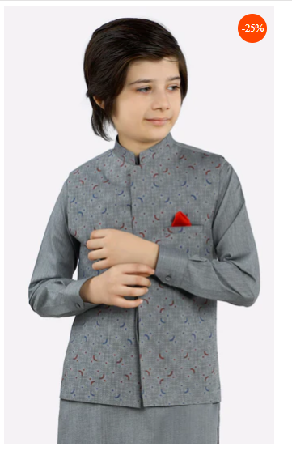

In the above picture the 25% discount is child div / tag and the picture is the parent div / tag

6. Write the HTML and CSS code snippet to make a table with alternate row colors (striped table).

_______________________________________________________________________________________________________________

Section C: Practical Questions (6 × 10 = 60 Marks)

(Each question carries 10 marks. Attempt any six.)

1. Create an HTML page with 3 different heading levels and style each heading differently using CSS (e.g., different colors, sizes, and alignments).

2. Write HTML code to create a form with fields: Full Name, Email, Password, Gender (radio buttons), Hobbies (checkboxes), and a Submit button. Add proper labels.

3. Design a table in HTML to display a student’s marksheet with columns: Subject, Marks Obtained, and Grade. Apply CSS for borders, padding, and center alignment.

4. Create an HTML page with two paragraphs. Style the first paragraph with italic text and blue color, and the second paragraph with bold text and red color using CSS classes.

5. Write HTML and CSS code to create a navigation bar using Flexbox, where menu items are equally spaced across the screen.

6. Create a <div> with width 300px and height 200px, positioned at the center of the browser window using position: absolute;. Add a background color of your choice.

7. Write HTML and CSS code to create an unordered list styled as a horizontal navigation menu with no bullets.

8. Design a responsive layout using Flexbox with three <div> blocks (Left, Center, Right) where the center block takes double the space of the left and right blocks.